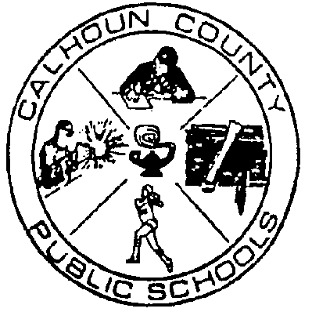Calhoun County Public Schools
School Emergency Responses: A Message to Parents

The following information is shared to help parents understand the prevention and preparation initiatives that are in place to keep Calhoun County Public Schools’ (CCPS) students and employees safe, how schools respond during and after an emergency, and how parents can play a vital role in each phase.

Prevention

- In addition to traditional fire and tornado drills, CCPS works proactively with the Calhoun County Sheriff’s Office, the St. Matthews City Police Department, Calhoun County Fire and EMS, and other human services agencies on behalf of the safety of our students and staff.

Preparation

- Each school has a plan in place to manage emergencies that may arise. Plans are developed with input from the Sheriff’s Office and other law enforcement agencies.

- Depending upon the situation, the plan may include evacuation of students and staff to another location or locking down the building and not allowing students to leave their classroom. Under these conditions, only authorized personnel will be allowed entrance to the school.

- Like fire and tornado drills, intruder drills have been added to school emergency management plans. These drills allow students and staff members to practice effective responses to unauthorized intruders on school property.

- There may be times when parent volunteers may be enlisted to provide assistance with security in the schools (i.e., monitoring entrances and exits; welcoming visitors and providing visitors badges, etc.). Individual schools will coordinate volunteer efforts along these lines.

Response

For several important reasons, many specific details about response plans are not shared publicly. However, it is important for parents to understand the following:

- Safety is the priority for staff at the school when an emergency is unfolding. Staff members and first responders will be focused on managing the emergency and taking care of the students.

- As soon as accurate information is available, it will be shared with Emergency Contact Persons (ECP)

- As soon as accurate information is available, it will be shared with parents as follows:

- Parents of individual students directly involved in the event
- Parents of students indirectly involved in the event
- School Board and staff
- Local media as appropriate

- Information will be shared using one or more of the following methods:

- Individual contact with parents of students directly involved in an emergency
- Letter from principal
- Notification All Call System to Parents
- The district website www.ccpsonline.net
- Local media

- The school district understands the anxiety that parents feel when there is potential danger to children. Probably the most difficult, but a very important way that parents can assist schools in responding effectively to emergencies, is NOT to call or come to the school during an emergency.
- Telephone lines will be needed for emergency outgoing calls.
- In the case of an intruder or other terrorist activity, schools will be locked down and only authorized personnel will be permitted to enter or exit buildings.
- The Calhoun County Sheriff’s Office or St. Matthews City Police may block access roads.
- Information about how and where to connect with your child will be provided as soon as possible through the Notification All Call System to Parents, the website, and local media.

Recovery

- School counselors and other human services professionals will be available to work with individuals and groups of students who may need help working through fear or grief following such an event.

- Following the emergency, school leaders, teachers, students, parent representatives and other community partners will review and evaluate the lessons learned.

- Adjustments to school security measures and emergency response plans will be recommended as appropriate and will become part of the prevention efforts of the school district.

