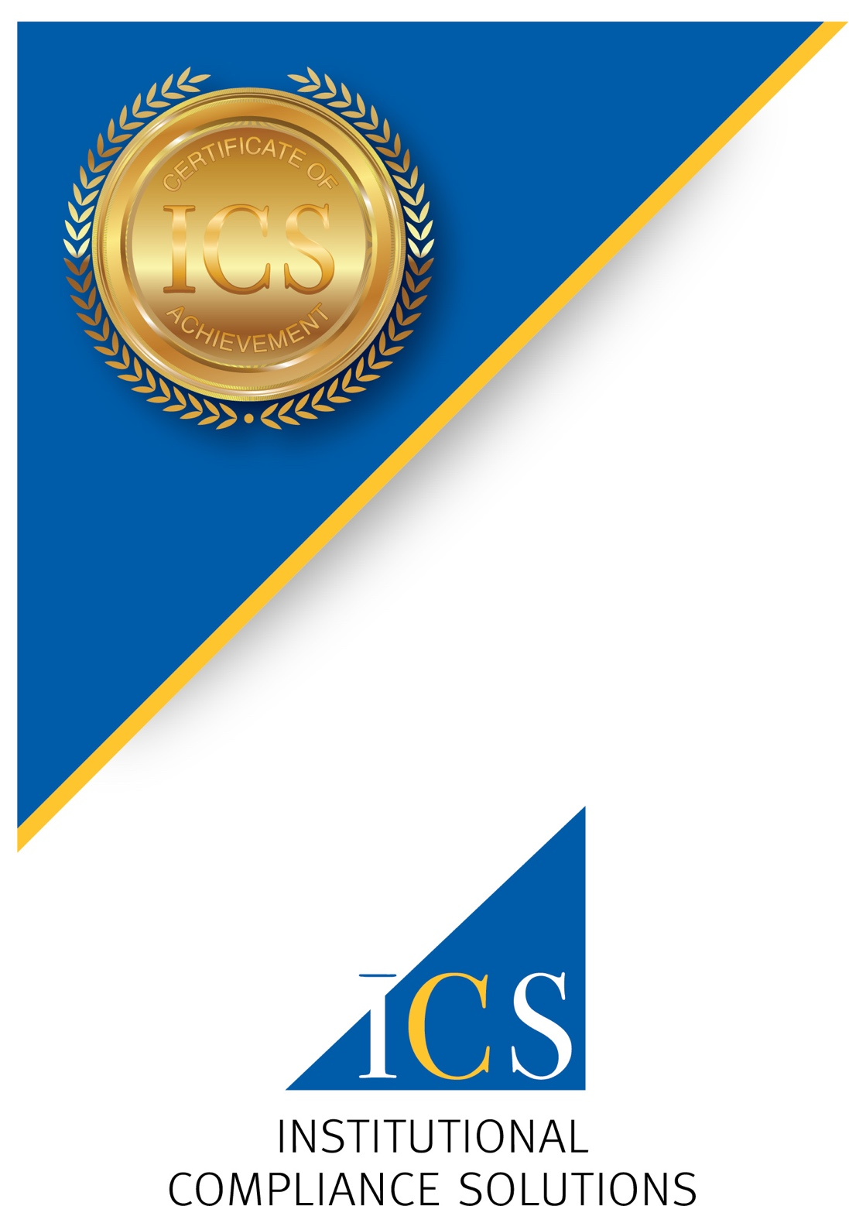

Certificate of Training

is awarded to

*George Kiernan*

by Institutional Compliance Solutions

for successfully completing

**K-12 Virtual Certified**

**Title IX Coordinator Training**

**(4 hrs)**

Date

*July 30, 2020*